Machine Learning
- B
- D
- D
- A
- B
- D
- A
- B
- D
- A
- D
- A
- How is cluster analysis calculated?
Solution : The cluster analysis is calculated by following three basic steps: 1) calculate the distances, 2) link the clusters, and 3) choose a solution by selecting the right number of clusters.
- How is cluster quality measured?
Solution : To measure a cluster's fitness within a clustering, we can compute the average silhouette coefficient value of all objects in the cluster. To measure the quality of a clustering, we can use the average silhouette coefficient value of all objects in the data set. The silhouette coefficient and other intrinsic measures can also be used in the elbow method to heuristically derive the number of clusters in a data set by replacing the sum of within-cluster variances.
- What is cluster analysis and its types?
Solution :
Cluster analysis : Cluster analysis is the task of grouping a set of data points in such a way that they can be characterized by their relevancy to one another.
There are four types of cluster analysis. These are :
- Centroid Clustering
- Density Clustering
- Distribution Clustering
- Connectivity Clustering.

SQL
- D
- A,C
- B
- C
- A
- C
- B
- B
- D
- c
- What is data-warehouse?
Solution : A data warehouse is a relational database that is designed for query and analysis rather than for transaction processing. It usually contains historical data derived from transaction data, but it can include data from other sources.
- What is the difference between OLTP VS OLAP?
BASIS FOR COMPARISON | OLTP | OLAP
Basic | It is an online transactional system and manages database modification. | It is an online data retrieving and data analysis system.
Focus | Insert, Update, Delete information from the database. | Extract data for analyzing that helps in decision making.
Data | OLTP and its transactions are the original source of data. | Different OLTPs database becomes the source of data for OLAP.
Transaction | OLTP has short transactions. | OLAP has long transactions.
Time | The processing time of a transaction is comparatively less in OLTP. | The processing time of a transaction is comparatively more in OLAP.
Queries | Simpler queries. | Complex queries.
Normalization | Tables in OLTP database are normalized (3NF). | Tables in OLAP database are not normalized.
Integrity | OLTP database must maintain data integrity constraint. | OLAP database does not get frequently modified. Hence, data integrity is not affected.

- What are the various characteristics of data-warehouse?
Solution :
The key characteristics of a data warehouse are as follows:

Some data is denormalized for simplification and to improve performance

Large amounts of historical data are used

Queries often retrieve large amounts of data

Both planned and ad hoc queries are common

The data load is controlled

- What is Star-Schema?
Solution : Star schema is the fundamental schema among the data mart schema and it is simplest. This schema is widely used to develop or build a data warehouse and dimensional data marts. It includes one or more fact tables indexing any number of dimensional tables. The star schema is a necessary case of the snowflake schema. It is also efficient for handling basic queries.
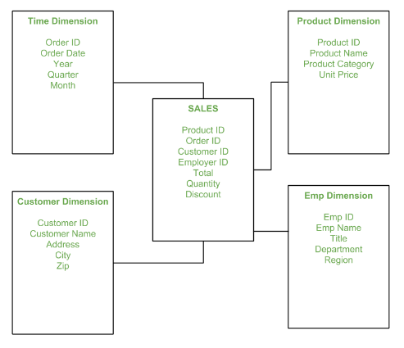
It is said to be star as its physical model resembles to the star shape having a fact table at its center and the dimension tables at its peripheral representing the star’s points. Below is an example to demonstrate the Star Schema:

- What do you mean by SETL?
Solution : Short for Set Theory as a Language (or Set Language), SETL is a high-level programming language that’s based on the mathematical theory of sets. It was developed in the early 1970’s by mathematician Professor J. Schwartz. SETL is an interpreted language with a syntax that is resembles C and in many cases similar to Perl. In SETL every statement is terminated by a semicolon. Variable names are case-insensitive and are automatically determined by their last assignment.

Statistics
- a
- a
- b
- d
- c
- b
- b
- a
- c

- What do you understand by the term Normal Distribution?

Solution : Normal distribution, also known as the Gaussian distribution, is a probability distribution that is symmetric about the mean, showing that data near the mean are more frequent in occurrence than data far from the mean. In graph form, normal distribution will appear as a bell curve.
- How do you handle missing data? What imputation techniques do you recommend?
Solution : There are many ways one could handle missing data .Some specific ways of handling this with imputation are :

- Imputation with mean : Missing data is replaced by mean of the column
- Imputation with median : Missing data is replaced by mean of the column
- Imputation with Mode: Missing data is replaced with mode of the column
- Imputation with linear regression : With real valued data, this is a common technique. The missing value is replaced by performing linear regression based on the other feature values.
- Multivariate Imputation by Chained Equations (MICE) MICE assumes that the missing data are Missing at Random (MAR). ...
- Random Forest.
When there are continuous data then I suggest with mean.For discrete data I suggest mode.
- What is A/B testing?
Solution : A/B testing is basically statistical hypothesis testing, or, in other words, statistical inference. It is an analytical method for making decisions that estimates population parameters based on sample statistics.
- Is mean imputation of missing data acceptable practice?
Solution :
Bad practice in general
- If just estimating means: mean imputation preserves the mean of the observed data
- Leads to an underestimate of the standard deviation
- Distorts relationships between variables by “pulling” estimates of the correlation toward zero

- What is linear regression in statistics?
Solution : In statistics, linear regression is a linear approach to modelling the relationship between a scalar response and one or more explanatory variables (also known as dependent and independent variables).
- What are the various branches of statistics?
Solution :
- Descriptive Statistics
The branch of statistics that focuses on collecting, summarizing, and presenting a set of data.

EXAMPLES : The average age of citizens who voted for the winning candidate in the last presidential election, the average length of all books about statistics, the variation in the weight of 100 boxes of cereal selected from a factory's production line.

- Inferential Statistics
CONCEPT : The branch of statistics that analyzes sample data to draw conclusions about a population.
EXAMPLE : A survey that sampled 2,001 full-or part-time workers ages 50 to 70, conducted by the American Association of Retired Persons (AARP), discovered that 70% of those polled planned to work past the traditional mid-60s retirement age. By using methods discussed in Section 6.4, this statistic could be used to draw conclusions about the population of all workers ages 50 to 70.

